|  |  |
| --- | --- |
|  |  |
| *Optical Mark Recognition* |  |
|  |  |
|  | June 8, 2021Ahmed Ahmed ElrewaidyAhmed Nabil lotfyEslam Khalid ElfauomyAkram Hesham RagabBasma Mohamed Ahmed |

### TABLE OF CONTENT:

* Edge Detection
* Drawing Contours over detected edges
* Find Sorted Rectangles
* Rearrange Points to meet questions table corners
* Drawing Contours over questions table

# Edge Detection:

Canny edge detector is strong enough to detect almost all the edges in our sheet like shown in the figure below.

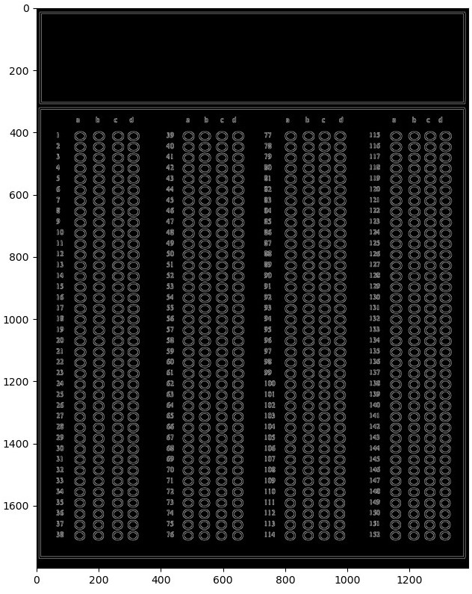

Fig 1 image with canny detection.

# Drawing Contours over detected edges:

In order to make use of our edges we have to draw contours above them to recognize shapes and do our calculations on them. The result is in the figure below.

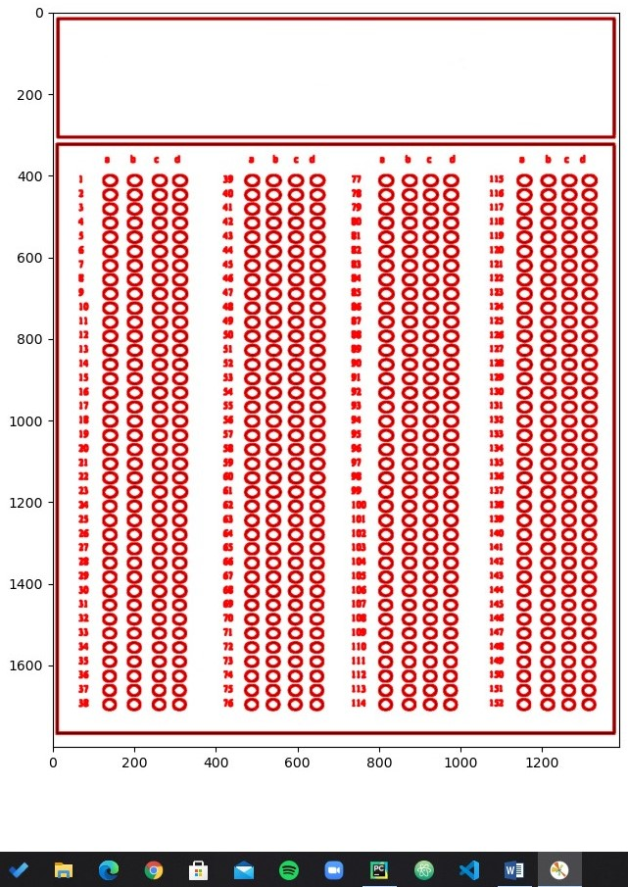

Fig 2 contours

# Find sorted rectangles:

There are so many implementation details in this one, but in short we detect only contours that have 4 corners (rectangles) with an area threshold, meaning that any contour having 4 corner and area that is greater than some threshold will be taken. We sort them descending as we are interested in the biggest rectangle which is the question table. The figure below will draw only the rectangles passed the given threshold and ignore all the others.

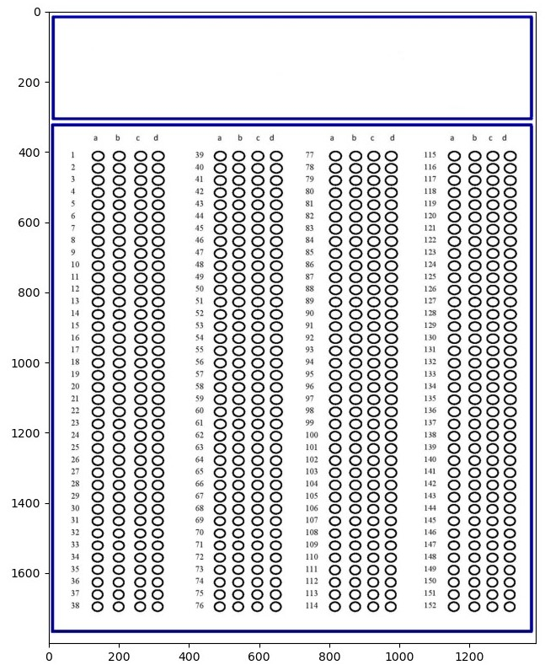

Fig 3 rectangle contours

Apparently, there are only two rectangles in the image. We are interested in the bigger one.

# Rearrange points to meet questions table corners:

Now that we have the contours of the questions, we can make its corners our new image to work in it individually. Figure below shows the result.

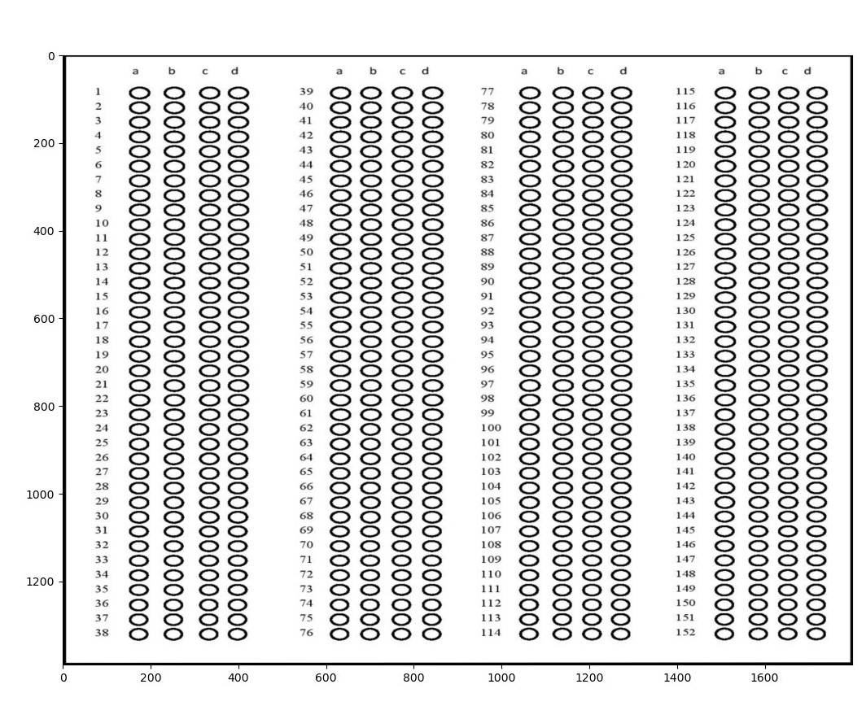

Fig 4 question box as a new image.

A little squashed and distorted right? So, what is the solution for this? We can fix this by adjusting the aspect ratio and giving it more height to its width. The result is in figure 5 below.

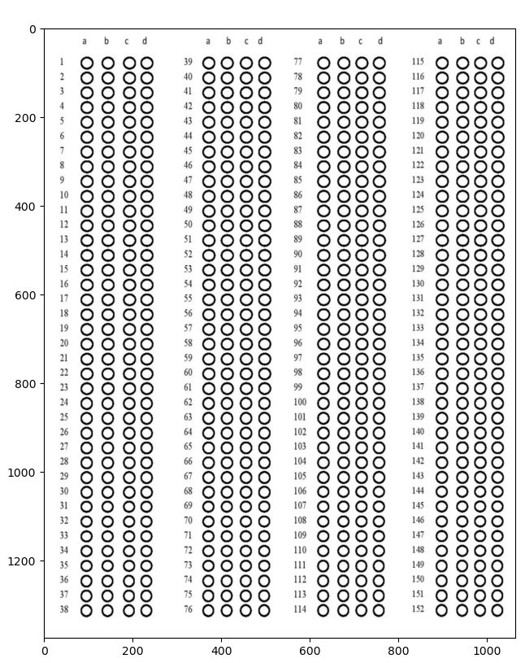

Fig 5 aspect ratio maintained

That is great! Looks exactly as we want it to be. Now to the next step.

# Drawing contours over questions table (again).

In this step we will repeat most of the steps above once more but now on the questions table which is basically our new image. We are interested in the contours inside this question image, more specifically we are interested in the circles inside of it.